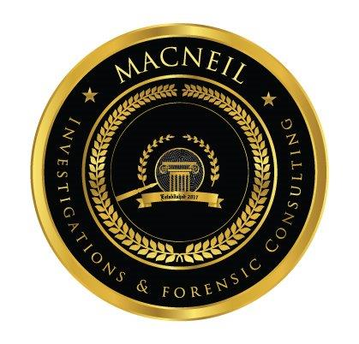

MacNeil Investigations & Forensic Consulting

Forensic Macro Photography/ALS

Register Now! Class Size is Limited
Cost: $179.00 per attendee
Date: TBD (1 day / 8hours)
Times: 0830-1630

REGISTRATION FORM
Course Location: TBD
Name (to be printed on certificate)

Police Department/Agency

Mailing Address: |  |  | Telephone:
City: |  | State: | Zip Code:
Your Email: |  | Emergency Contact:
Payment Method: | PO (must be attached)  Check | Master Card  Visa
Name on Card: | Credit Card Number: |  | Expiration Date:
Billing Address (if the same as mailing address check here ) |  |  | Telephone:
City |  | State: | Zip Code:
Please email completed registration to: training@macneilpi.com
Full payment is required prior to first day of class. Cancellations will be handled as follows: cancellations made 45 days prior to the first day of class will receive a full refund; cancellations made within 30-44 days will be refunded at 50% of the course cost; and cancellations made less than 30 days will not be refunded.
Attendees will receive written course confirmation prior to the course start date.
MacNeil Investigations & Forensic Consulting reserves the right to cancel the above course due to unforeseen circumstances outside of our control; we strongly encourage necessary travel arrangements to be made upon written confirmation.

